LIT

a short film by elena oxman

electronic press kit

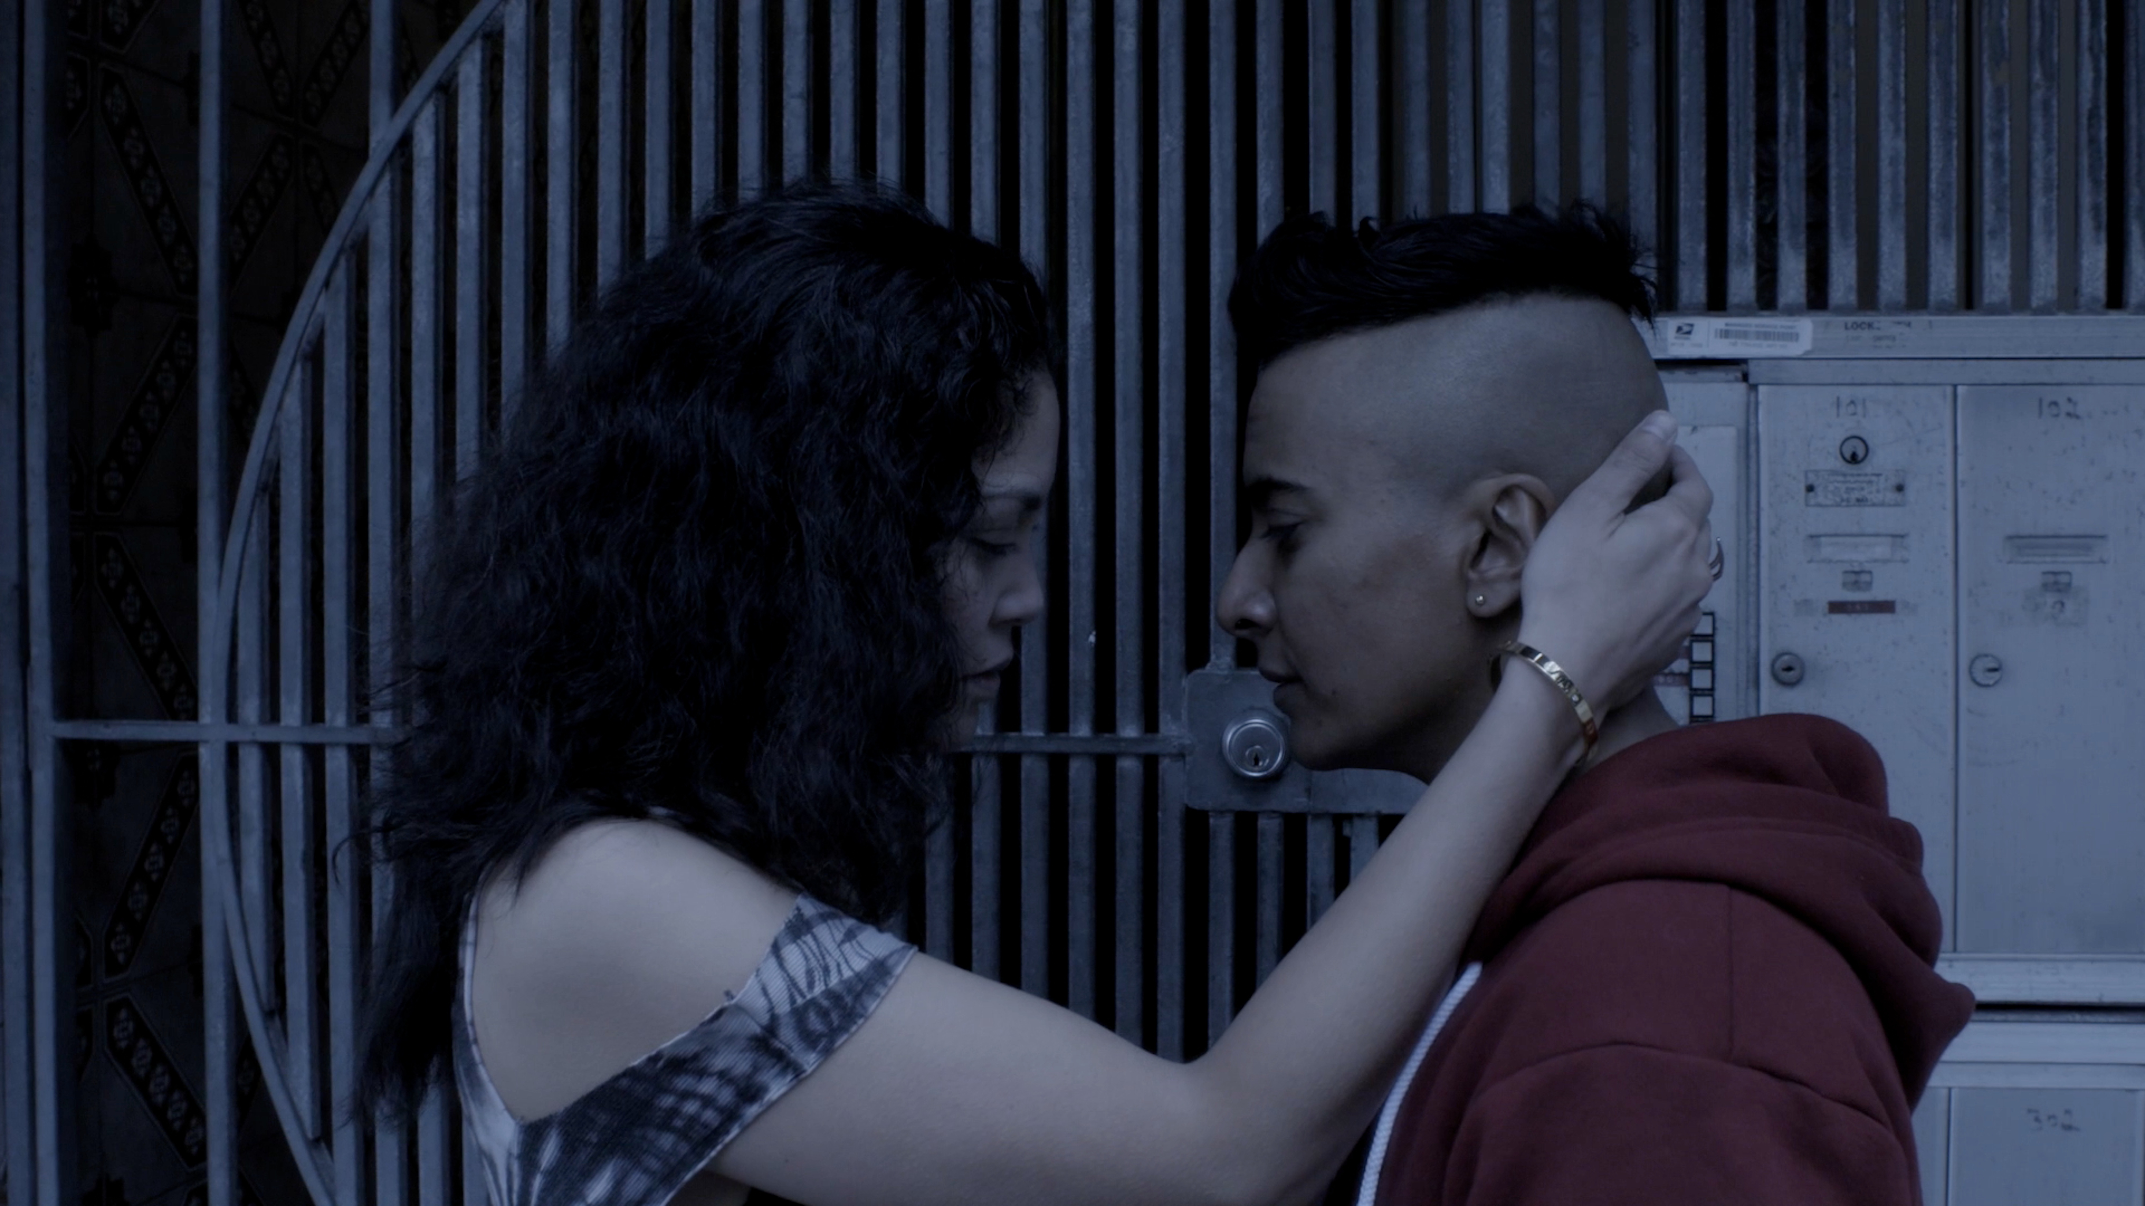

synopsis

Eva and Jessie meet at a bar at last call and begin a late night crawl around San Francisco. What seems like a one night stand goes in a different direction when Eva makes revelations about her life.

cast/crew

writer/director: Elena Oxman

producer: Giacomo DiGrigoli

director of photography: Tijana Petrovic

editor: Chris Dobbins

starring:

D’Lo………………….Jessie

Rinabeth Apostal…...Eva

Liz Anderson……… Bree

Noelle Skool………...WTF girl

production design: Ana Landis Velazquez

costume design: Glenda La Marr

hair and makeup: Melissa Capistrano

casting director: Tina D’Elia

assistant director: Cameo Wood

script supervisor: Leslie Tai

1st assistant camera: Satsuki Murashige

Dean Snodgrass

Andy Hoffman

2nd assistant camera: Theresa Wong

Tobias Levene

Megaera Stephens

steadicam: Benjamin Casias

gaffer: Hector Aranda

Chris Dobbins

key grip: Steve Forbes

grip: James Nagel

colorist: Chris Tipton-King

original score: Matt Whyte

supervising sound editor: Kadet Kuhne

assistant sound design: Michael Marinucci

Omid Moayedi

ADR recordist: Geoff Norman

sound recordist: Keenan Jensen

Paul Dorough

Shawn Doyle

boom operator: Paige Goedkoop

production assistants: Nick Manousos

Iyeon Kim

Sooji Kim

Sky Haneul Kim

“Empty Dragon”
Written by CDK
Performed by CDK and Jonser 5
Licensed under Creative Commons

“Fashion”
Written by Matt Whyte
Performed by Earl Greyhound
Courtesy of Hawk Race Records
Published by Songs Music Publishing/Dreamwar (BMI)

“Try it”
Written by JenRo
Performed by JenRo
Courtesy of RO Records

“Wild Horse”
Written by Chiara Angelicola and Bryan Senti
Performed by Bird Call
Courtesy of Found Objects Entertainment

Film & Lighting Equipment Supplied by Videofax and Little Giant Lighting & Grip

director biography

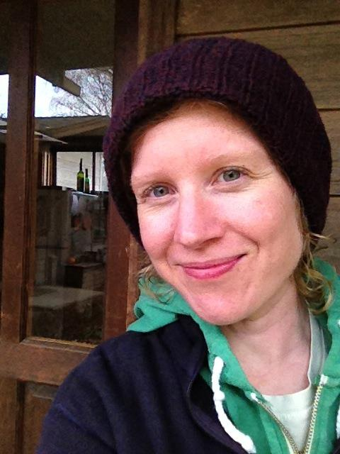
Elena Oxman is the co-founder of the documentary production company American Beat (http://americanbeatfilms.wordpress.com). Her award-winning essay-film, Kmart Confidential (link: https://vimeo.com/43187794) has screened nationally and internationally. In 2012, she received her Ph.D. from the University of North Carolina at Chapel Hill, where she wrote a dissertation on French film theory and criticism. She currently teaches classes in film history, theory, and production at Stanford University and College of San Mateo.

